Problem 3 - Grocery Shopping
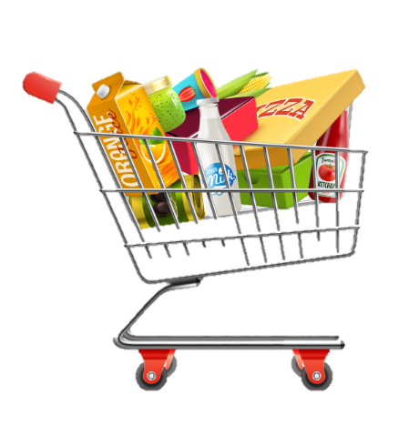
Jane made a list of products, which she must buy from the nearest supermarket. While completing her list, Jane checks the products in her home.
On the first line, you will receive a sequence with products, split by "|". On the following lines, until command "Shop!", you will be receiving commands. The possible commands are:
- "Important%{product}":
- If the product exists, move it to the beginning of the list (index 0).
- Otherwise, add it to the list at the 0 index.
- "Add%{product}":
- If the product did not exist – add it at the end of the list.
- Otherwise, print: "The product is already in the list."
- "Swap%{product}%{product}":
- If both products exist – swap their places.
- If one of the two products is missing, print: "Product {product} missing!"
- There is no case in which both products are missing at the same time.
- "Remove%{product}":
- If the product is in the list, remove it.
- Otherwise, print: "Product {product} isn't in the list."
- "Reversed":
  - Reverse the list of products.
When you receive the command "Shop!" you should print each product from the list on a new line with its number in the list (starting from 1) and end the program:
"1. {product1}
2. {product2}
…
N. {productN}"

Input
- On the first line, you will receive a sequence with products, split by "|".
- On the following lines, until the command "Shop!", you will be receiving commands.

Output
- Print the output needed as described above.

Examples
Input | Output
eggs|milk|bread|fish  Important%bread  Swap%eggs%tomato  Shop! | Product tomato missing!  1. bread  2. eggs  3. milk  4. fish
apple|cheese|salt|bananas  Remove%cheese  Swap%salt%bananas  Shop! | 1. apple  2. bananas  3. salt
kiwi|paper|coffee  Add%coffee  Important%bread  Shop! | The product is already in the list.  1. bread  2. kiwi  3. paper  4. coffee

JS Examples
The input will be an array of strings.
Input | Output
(["eggs|milk|bread|fish",  "Important%bread",  "Swap%eggs%tomato",  "Shop!"]) | Product tomato missing!  1. bread  2. eggs  3. milk  4. fish
(["apple|cheese|salt|bananas",  "Remove%cheese",  "Swap%salt%bananas",  "Shop!"]) | 1. apple  2. bananas  3. salt
(["kiwi|paper|coffee",  "Add%coffee",  "Important%bread",  "Shop!"]) | The product is already in the list.  1. bread  2. kiwi  3. paper  4. coffee

